# Analytical Calculations and Simulation

This section contains analytical calculations and simulations for flyback converters. Since the controllers, whose details will be explained later, force the system to operate in boundary mode, calculations will be made according to continuous current mode and values of components will be taken in accordance with boundary mode.

Duty cycle values close to ideal conditions are calculated as in the equation **1**. As a result of the research of the controller and transformer design, it was decided that the turn ratio value should be close to 4. Under normal conditions, considering the power loss and thermal conditions, the transformer ratio should be adjusted so that the duty cycle is optimally 0.5. However, due to the working mechanism of the controller selected in accordance with the project, the system will operate at low duty cycle.

|  |  |
| --- | --- |
| $$V_{out}=V_{in}\left(\frac{D}{1-D}\right)(\frac{N2}{N1})$$ | (1) |
| $$V_{in}=220 V , D=0.18;V_{in}=400 V , D=0.11$$ | (2) |

The minimum required inductance value for Continuous Current Mode depends on the frequency. The controller works with around 100kHz at input voltage values. The worst case has been taken into consideration in the calculations.

|  |  |
| --- | --- |
| $$L_{Mmin}=\left(\frac{{(1-D)}^{2}R}{2f}\right){(\frac{N1}{N2})}^{2}$$ | (3) |
| $${f=100 kHz, L}_{Mmin}=91.25μ H$$ | (4) |

When the switch is in off mode, the voltage falling on the switch is calculated in equation 5.

|  |  |
| --- | --- |
| $$V_{sw_open}=V_{in}+V_{out}*N, V_{sw_{max}}=448 V$$ | (5) |

The output voltage limit suitable for the project purpose is calculated according to the 7 and 8 equations. The worst case has been taken into consideration in the calculations.

|  |  |
| --- | --- |
| $$ΔV_{o}=\frac{ΔQ}{C}=\frac{V_{o}*D*T_{s}}{R*C}, \frac{ ΔV_{o}}{V_{o}}≤0.04, C≥31.25 μF$$ | (7) |
| $$ΔV_{o,ESR}=I_{LM,max}*\left(\frac{N1}{N2}\right)*r_{c}, r_{c}<0.006 ohm$$ | (8) |

These calculated values are symbolic. It depends on the choice of components used and the mode in which the controller is operating. Therefore, after simulations with the controller, different calculations can be made using the same equations.

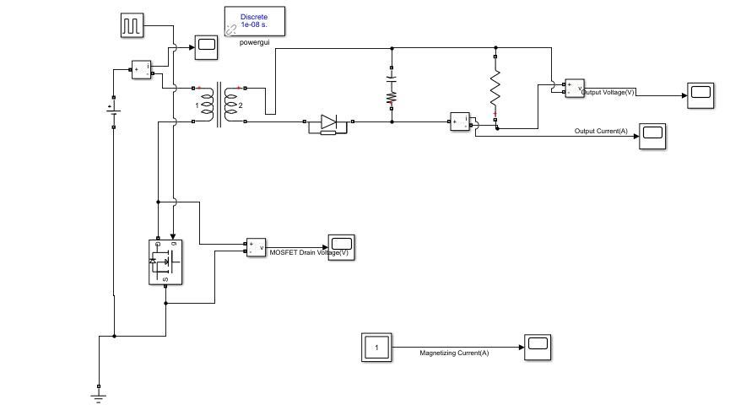Converter diagram was created with MATLAB-SIMULINK to test analytical calculations. In the model, the circuit elements are taken as the values in the analytical calculation.

Figure M1. Flyback Converter Simulink Model

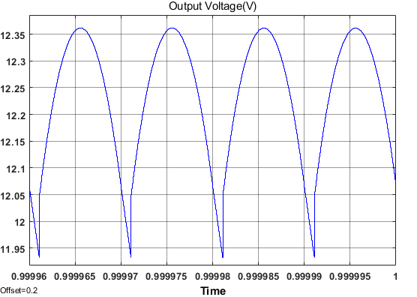While selecting the capacitor value, the ESR value of the capacitor was also considered. The output voltage ripple value is approximate to what was expected.

Figure M2. Output Voltage

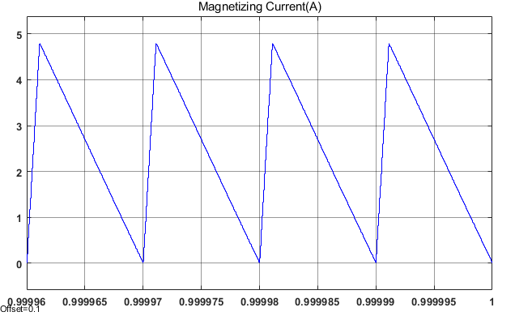

Figure M3. Magnetizing Current

It can be seen that the converter works in boundary mode from the magnetizing current in figure M3.

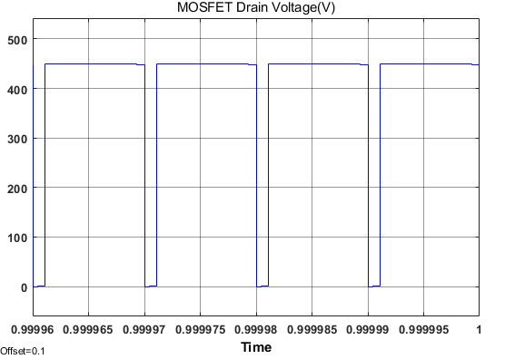

Figure M4. MOSFET Drain Voltage

The breakdown voltage falling on the MOSFET while in off mode is also seen in figure M4. The result is the same with the analytical model. This value should also be considered while choosing the MOSFET.

Analytical calculations and simulations made so far are the first step of the project. In later stages, these analytical equations were used iteratively. However, the controller directly affects the converter's duty cycle and frequency. Therefore, it is compulsory to make detailed simulation with the controller after the component selection. Components are selected iteratively according to the results of the simulations.